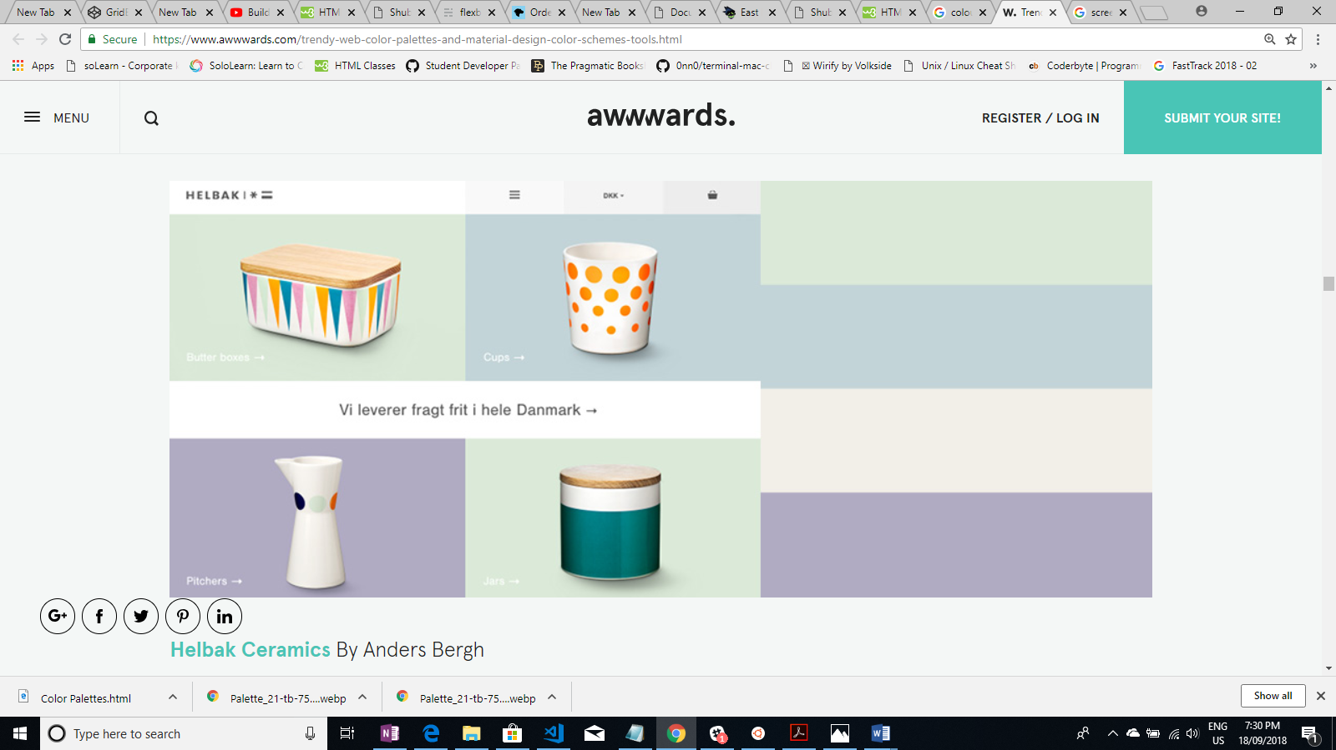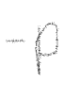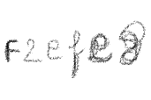d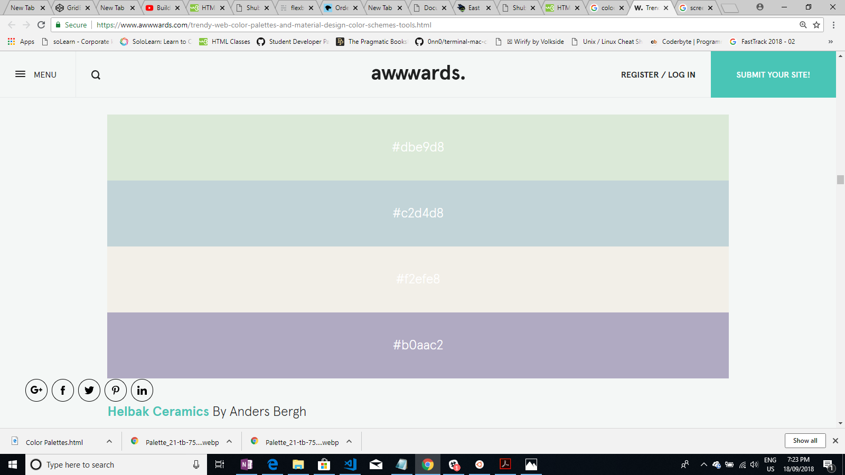



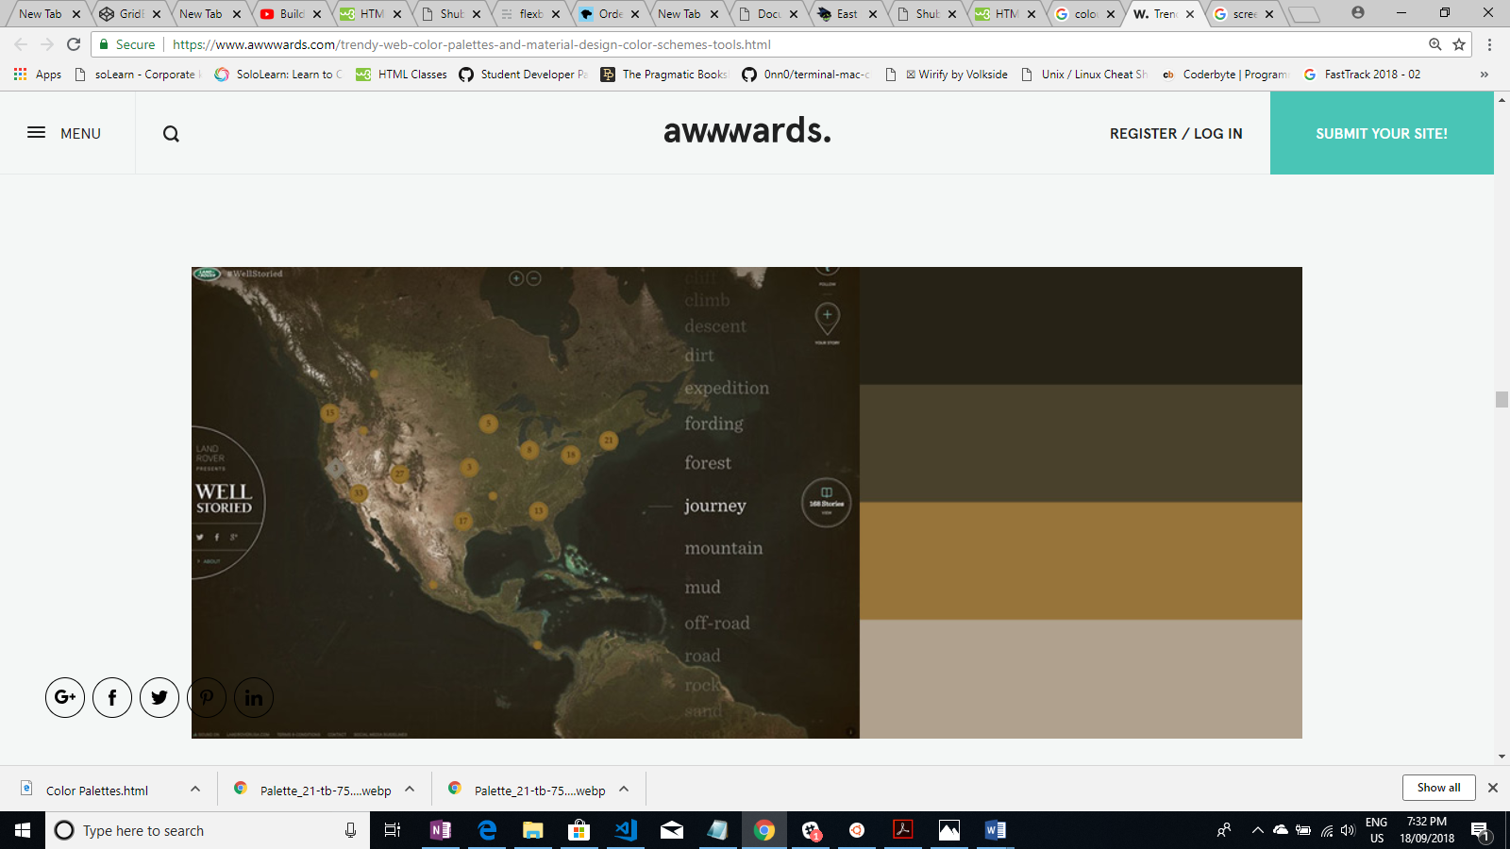

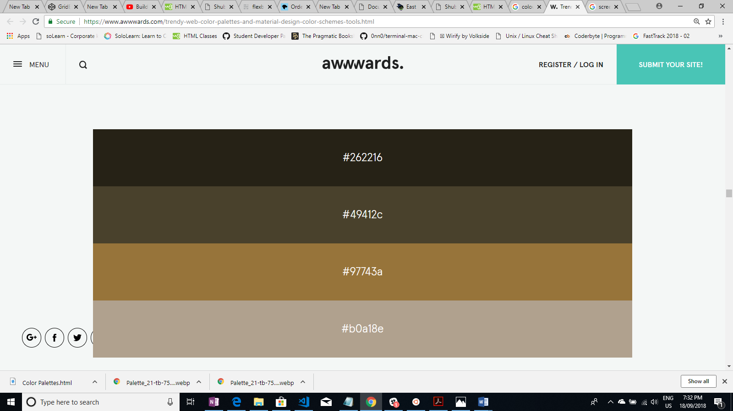

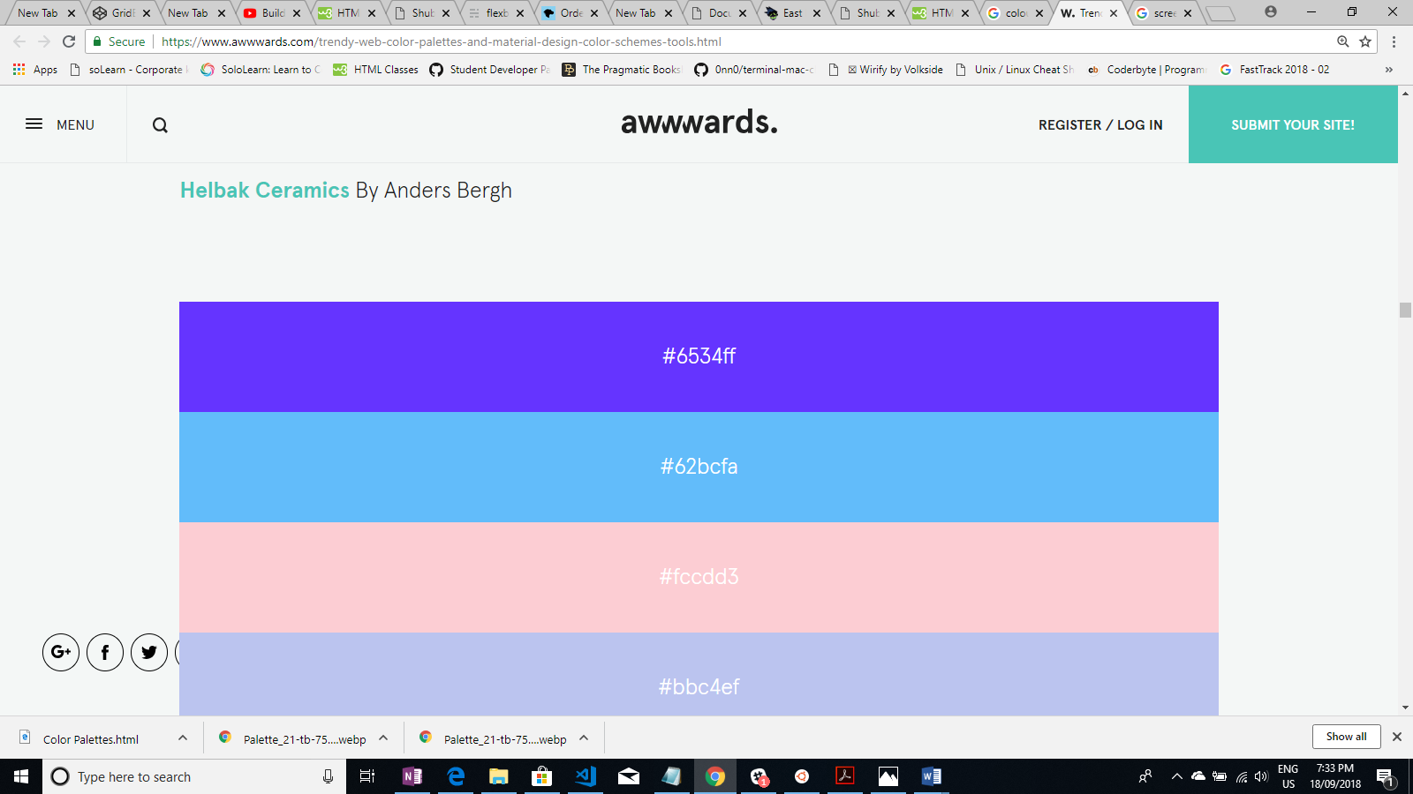

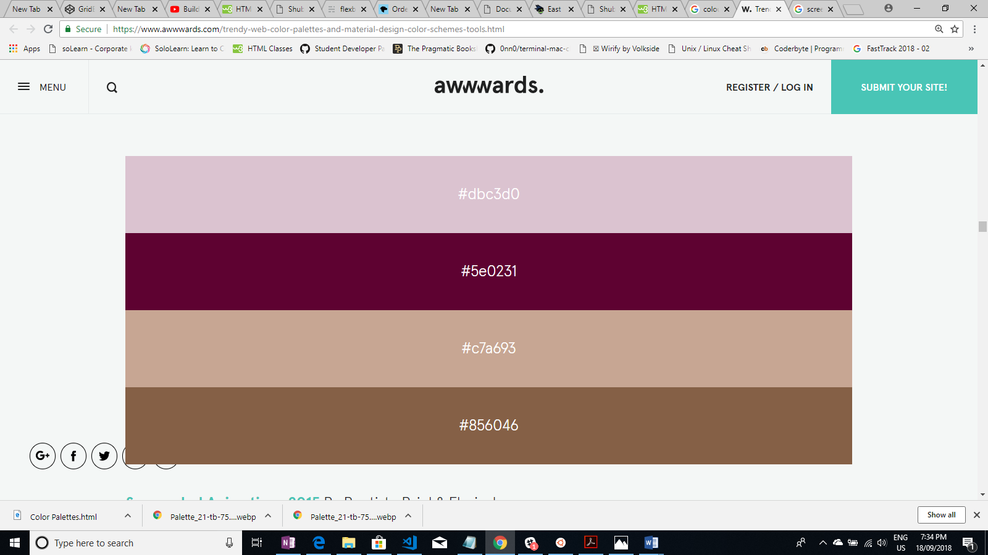

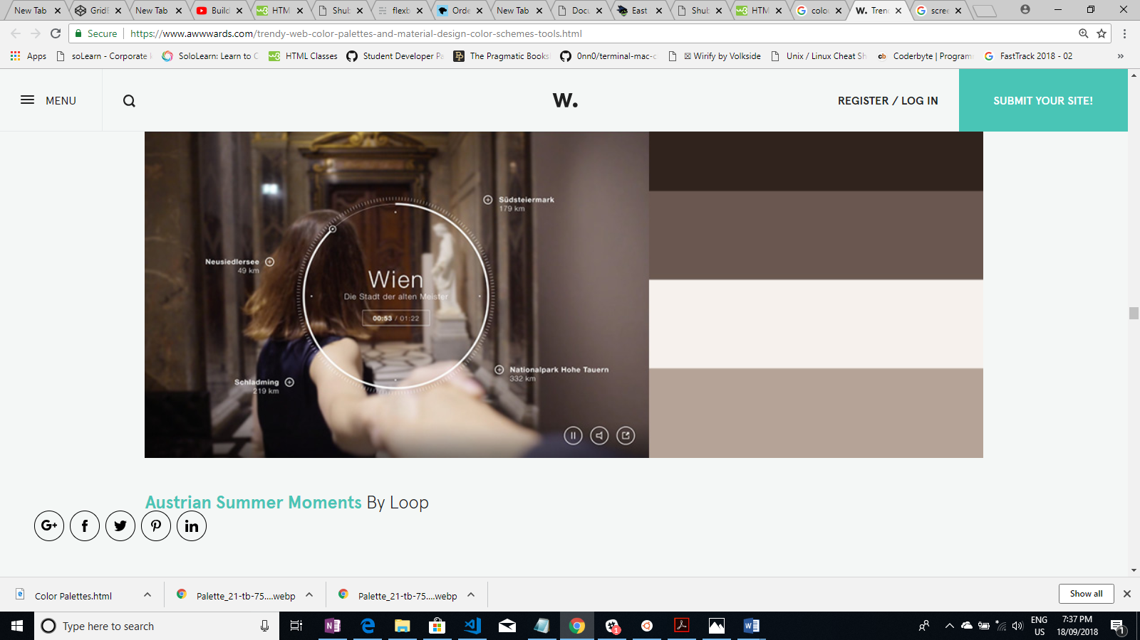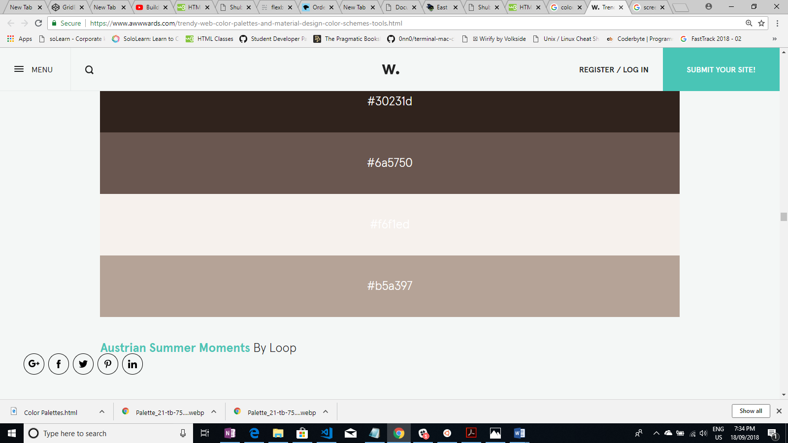



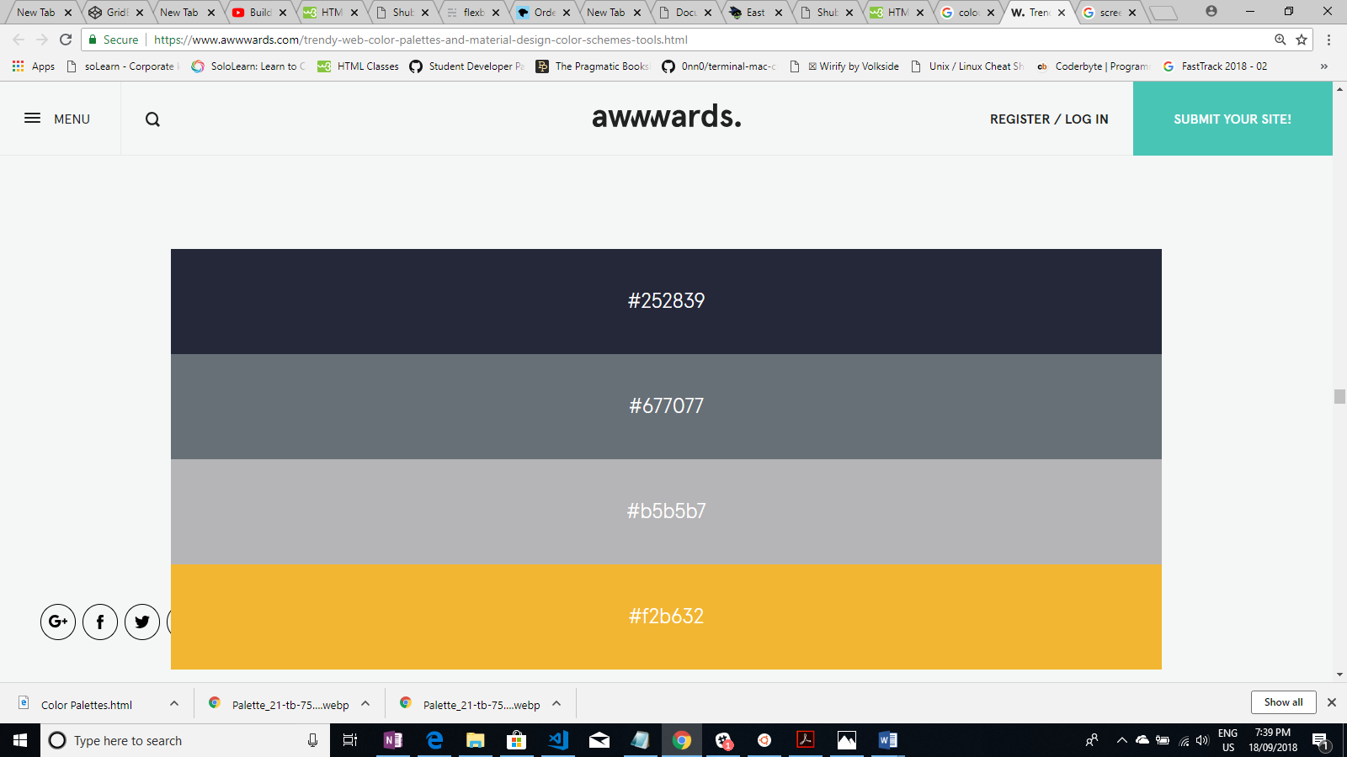

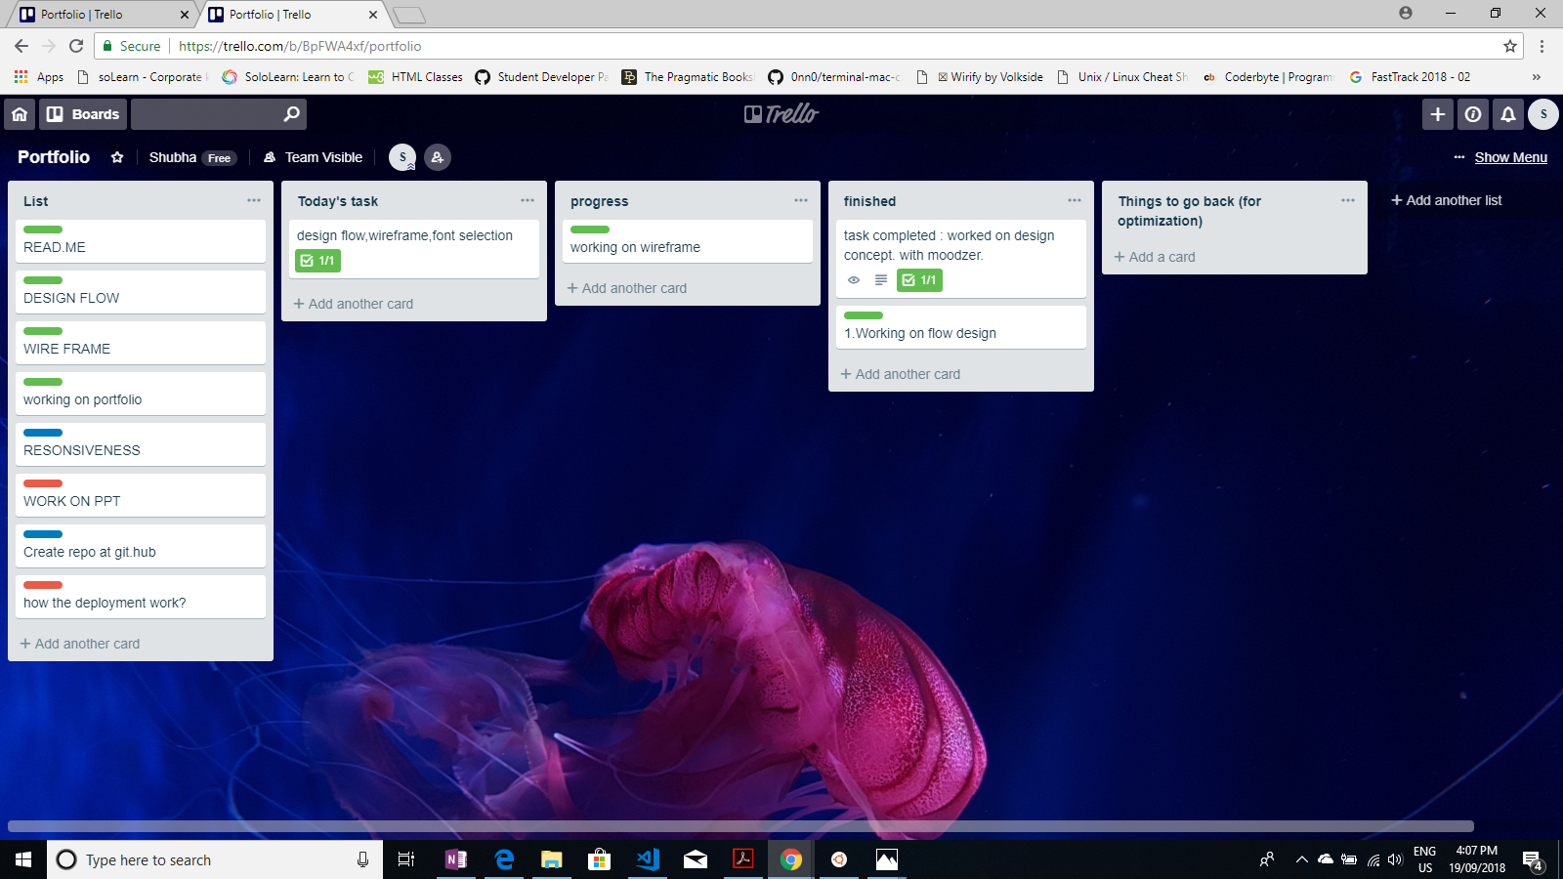

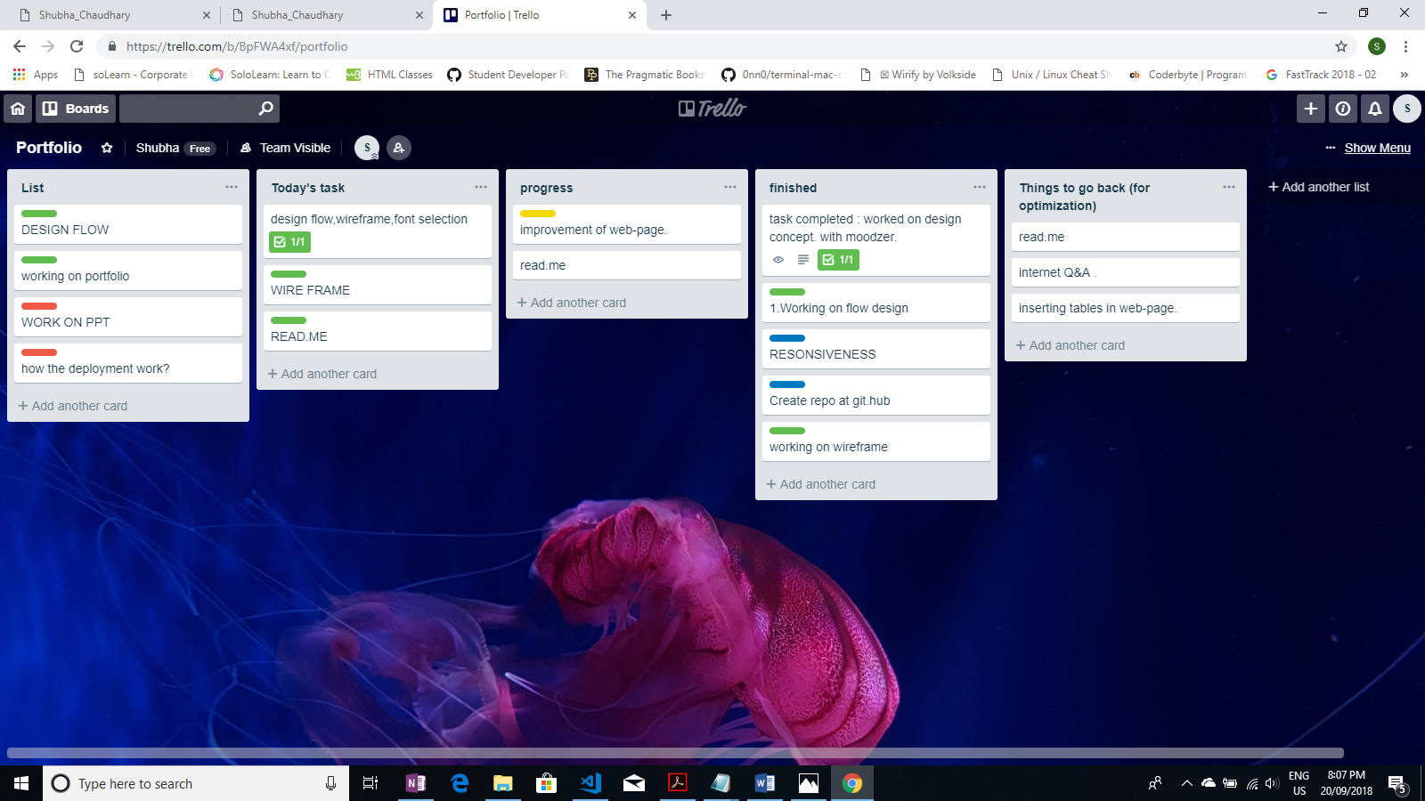

Making your icon:

Selected icon: Autumn leaf



**CONVERTED INTO SVG BY USING ONLINE APP:** JPG TO SVG COVERTED FILE.

Used iconmoon.io/app to get the Tag for html and Css file.

Css:

<script defer src="https://i.icomoon.io/public/temp/64e07a4ad0/UntitledProject/svgxuse.js"></script> -->

Html:

<svg class="icon icon-leaf"><use xlink:href="#icon-leaf"></use></svg>

Not satisfied with it completely and decided to go for font-awesome leaf icon

finally used icon : fontawesome leaf icon

